**1.INTRODUCTION**

**1.1 OVERVIEW**

India is currently the worlds second largest producer of several dry fruits, agriculture based textile raw materials, roots and tuber crops, pulses, farmed fish ,eggs, coconut, sugarcane and numerous vegetables. here we are going to see about the topic under Indias agricultural crop production Indias foodgrains production touched a record 315.7 million tonnes in 2021-22. And agriculture is the pillar and backbone job that every youngsters to be learn and do

**1.2 PURPOSE**

Agriculture is the practice of cultivating natural resources to sustain human life and provide economic gain. It combines the creativity, imagination, and skill involved in planting crops and raising animals with modern production methods and new technologies.

Agriculture is the foundation of the Indian economy. The population of india mostly depends on agriculture for their livelihood and agriculture contributes to 40 percent of the total GDP of the country.

**2.** **PROBLEM** **DEFINITION AND DESIGN THINKING**

2.1 **EMPATHY MAP**

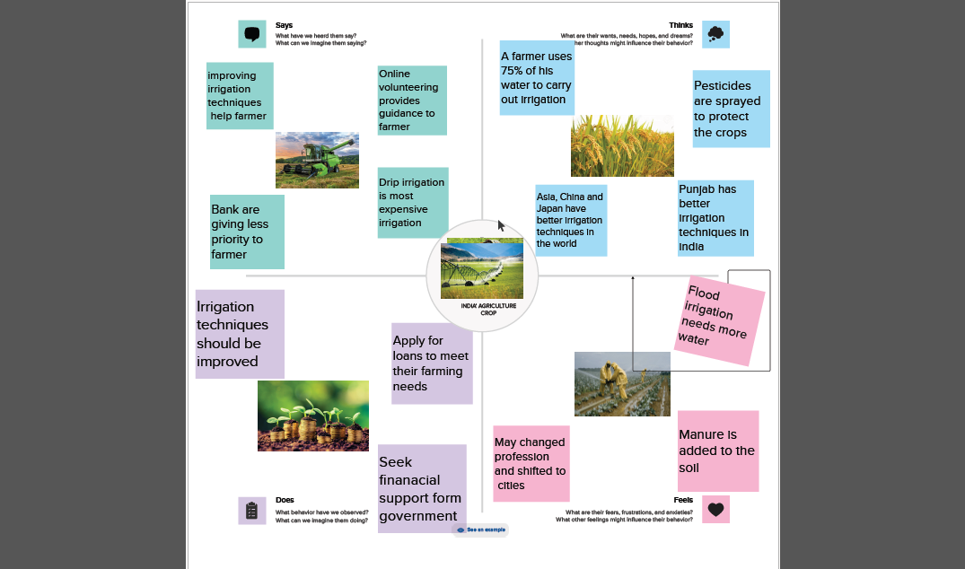

**2.2 IDEATION AND BRAIN STRORMIND MAP**

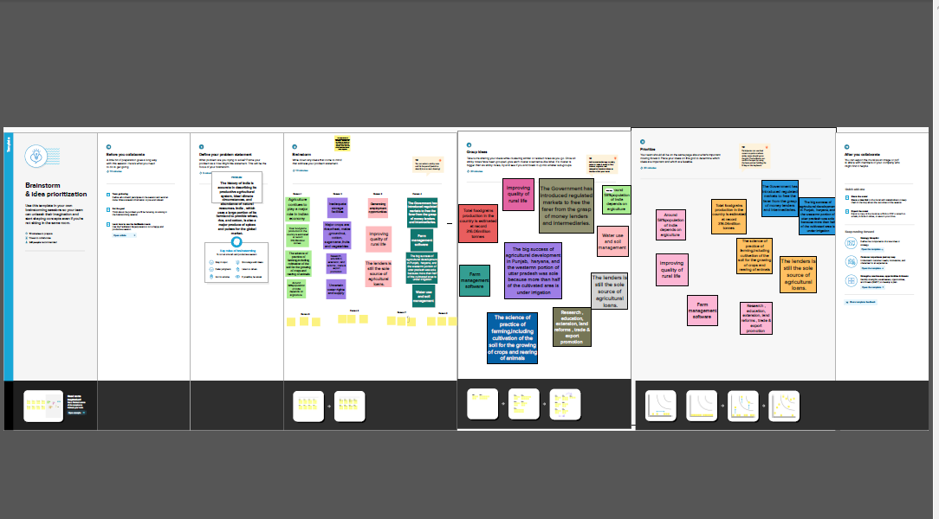

**3. RESULT**

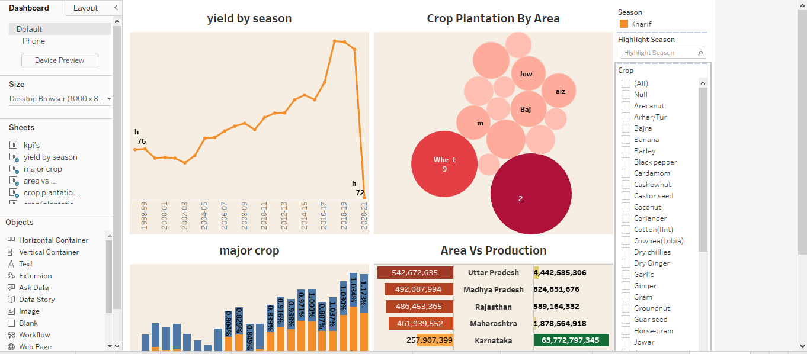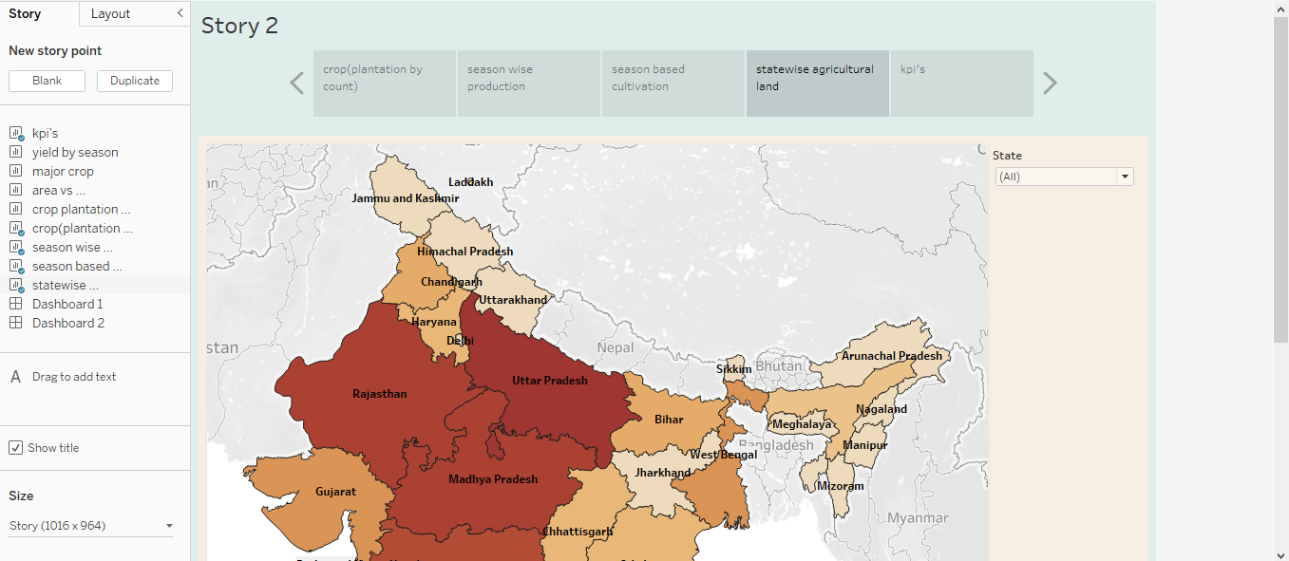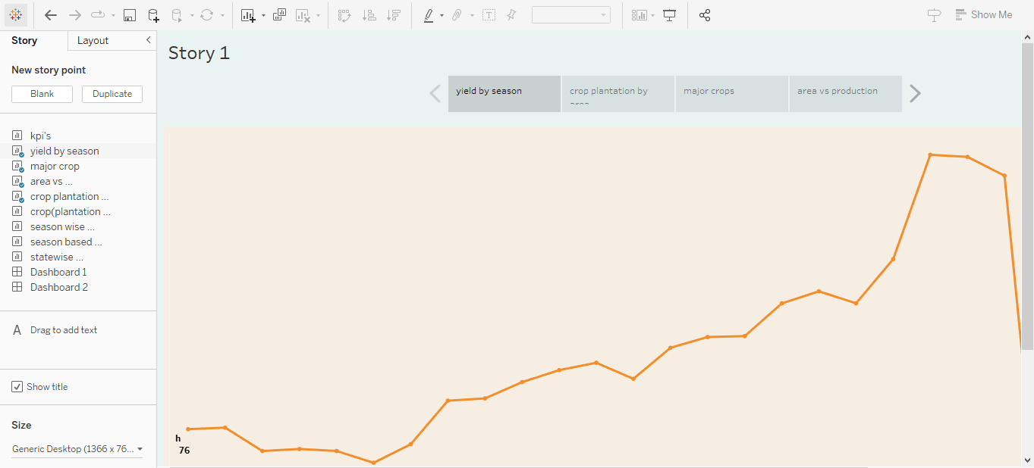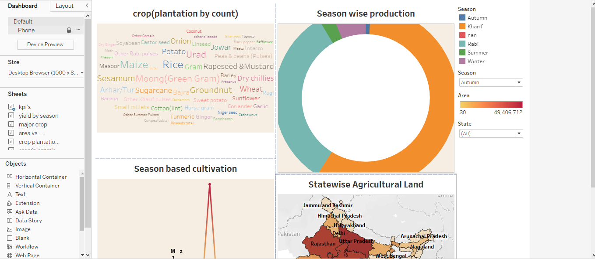

**4. ADVANTAGES AND DISADVANTAGES**

**ADVANTAGES**

These are following merits of the indias agriculture crop production. it aslo simplifies the method of production rates and cost of the production

1. there is over all increase in yield of crops mainly due to maintaining physical chemical properties of the soil.

2. it helps to controlling insects, pests and soil borne diseases. it also controls weeds during the culture.

3. prevent of limit period of peak requirements of irrigation water requiring high irrigation if followed by light irrigation.

**DISADVANTAGES**

these are some of the demerits of the crop production management it also implies the non production through the following cases.

1. intensive farming causes soil degradation and lead to the expansion of new lands. in some are deforestation.

2. pest and weed resistance to chemical that synthesized pesticides and herbicides

3. soil degradation and impact of natural habits with includes the water and land pollution.

**5.APPLICATIONS**

Agricultural applications means application relating to the following

1. cultivating, characterising or modifying the soil

2. producing, growing, improving, protecting, treating or modifying crops or forest products.

3. raising, harvesting, protecting treating or modifying livestock of the crop production.

**6.CONCLUSION**

In the conclusion agriculture has given so much to society, but it has its own prosperty and concerns that we cant overlook. furthermore, the government is doing his every bit to help in the growth and development of agriculture, sitll, it needs to do something for the negative impacts of agriculture. finnaly the indian economy is an agro-economy and depends highly on the agricultural sector.

**7.FUTURE SCOPE**

**YES,** Agriculture is good for the future as it is expected to use advanced technologies and innovations to produce more foods with limited land and resources, increase effeciency on farms, and become more profitable, efficient, safe and environment friendly

the greater the advanced stage of development of agricultural nations, the greater the contribution of agriculture to national earnings.